Anonymization Strategy for Discharge Reports at Erasmus MC
Authors: Tim Kortman, Robert van der Boon, Lucia Jewbali, Nico Bruining

Version 1.0 Date: 02-02-2026

Research proposal (short)
In collaboration with an external party, we are developing a multi-agent, multi-modal clinical decision support (CDS) tool based on large language model (LLM) technology. This language model has been combined with Retrieval‑Augmented Generation (RAG) on international cardiology guidelines. The prototype is designed to support guideline-based reasoning for cardiologists on duty in acute settings. Currently, the text-based agent has been developed and tested on synthetically generated medical data. The next step is to validate the performance of this tool on real-world data.
We therefore propose a retrospective study of the digital discharge letters of all cardiology patients seen in the emergency department since the introduction of Hix (2018-now). The model focuses solely on this textual content, and outcomes are compared with the conclusion of the discharge letter. Disagreements will be assessed by an adjudication panel consisting of junior and senior cardiologists. This study primarily provides insight into how well the model follows the prescribed guidelines and how the model outcomes differ from the way the Erasmus MC treated its patients.

Anonymization Pipeline
The developed model is currently running on a server outside Erasmus MC during the testing phase. To remain compliant with GDPR/AVG, letters will therefore have to be anonymized. To our knowledge, there is no standard protocol for this within EMC. We are therefore proposing our own method for careful anonymization of discharge letters. We are taking all measures that are reasonably possible with the current state of technology [1].

Automated anonymization
First, data are extracted from the EPD and internal pseudonymization is performed. All discharge reports are assigned to a unique study code. The key table (linking patient IDs to study codes) is stored on a secure, restricted-access folder within the Erasmus MC network, accessible only to the Principal Investigator (PI) and the data manager.
Note that we want to perform our study under “exception consent” with an opt-out check, so any patient with registered objection to reuse their medical data is excluded.
Before data then leaves het Erasmus MC environment, it undergoes a two-phase anonymization process. The automated stage of anonymization will be performed by a Named Entity Recognition (NER) algorithm. We found an open-source anonymization tool developed by the UMC Utrecht called DEDUCE [2]. This software is designed for Dutch health reports, can be run safe in a local environment and allows adjustments of functionality. For example, DEDUCE does not make external API calls and writes only cache files locally. The use of this software will adhere to the HIPAA Safe Harbor standard for identification criteria [3].

Identifiers
During the automated anonymization stage, identifiers are categorized based on their relevance to clinical reasoning. Direct identifiers, such as personal and contact details, hold no clinical utility, and will be fully redacted. Conversely, clinically significant data—including medical history and pharmacological therapy—will be preserved to maintain the diagnostic integrity required for the model's reasoning. Quasi-identifiers, such as age and socio-demographic markers, will be transformed into generalized categories. To safeguard privacy while preserving the chronological logic essential for clinical assessment, absolute dates will undergo temporal shifting into relative timeframes.

Manual anonymization
Normally, performance of an anonymization tool is assessed with the recall of a sample [4]. However, because we are only satisfied with a 100% recall of personal information for all data points, we manually check all letters.
Second stage manual anonymization will be performed by two independent assessors. This stage includes the potential correction for any residual identifiers or derivatives thereof and generalizing possible other indirect identifiers not found by DEDUCE / HIPAA standards. These other identifiers can include extreme rare co-mobilities or exceptional statuses that can be traced back to individuals.
The strategy that can be applied here is the more dynamic perspective for anonymization assessment as described by the Court of Justice of the European Union [5]. For each letter, we examine whether the recipient, with his/her available means, is able to re-identify the information, thereby adding a subjective “putting oneself in the shoes of” perspective to the objective automated method.

Synthetic alternative
Critical evaluation of AI models on real-world clinical data is the cornerstone for bringing AI into the clinic. Without mimicking actual clinical reality, we cannot prepare the model for the next step in that direction. Because the model has already been tested and trained on synthetic discharge letters, validating it with the same type of data is not effective.

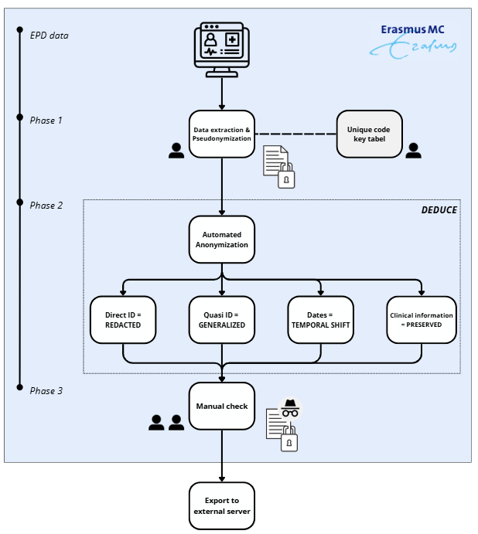
Figure 1: Schematic overview of the anonymization pipeline

References
- A Review of Anonymization for Healthcare Data | Big Data
- deduce/README.md at main · vmenger/deduce · GitHub
- HIPAA De‑Identification Safe Harbor Method: A Practical Guide
- Evaluation of Anonymization Tools for Health Data | Springer Nature Link (formerly SpringerLink)
- EUR-Lex - 62023CJ0413 - EN - EUR-Lex

